LeetCode Program 2520
Link :- https://leetcode.com/problems/count-the-digits-that-divide-a-number/
Successful Submission
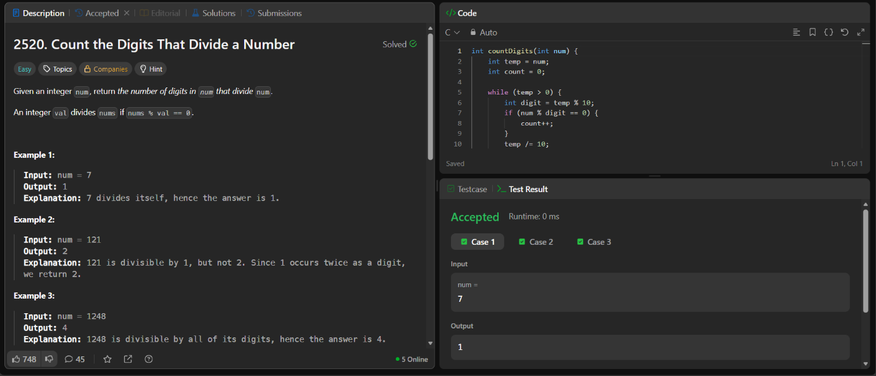
Source Code


